1. BI Engineer SQL Test #1

Buatlah SQL Statement untuk menampilkan metrics perusahaan dibawah ini:

* 1. Jumlah seluruh produk yang terjual

select sum(Quantity) AS 'Total Seluruh Produk' from superstore_orders

Output:



* 1. Jumlah unique customer yang telah memesan produk

select count(distinct [Customer ID]) as 'Jumlah Unique Customer' from superstore_orders

Output:



* 1. Rata-rata profit dari seluruh order (dalam mata uang)

select avg(Profit) as'Rata Rata Profit(USD)' from superstore_orders

Output:



* 1. Berapa discount terkecil dari seluruh order

select min(Discount) as'Discount Terkecil(USD)' from superstore_orders

where Discount!=0

Output:



* 1. Jumlah seluruh produk dari kategori Furniture

select count(Category) as'Jumlah Produk Furniture' from superstore_categories

where Category='Furniture'

Output:



* 1. Nama pelanggan yang membeli produk paling banyak (dalam quantity)

select top 5 o.[Customer ID], cm.[Customer Name], sum(o.[Quantity]) as 'Jumlah Produk' from superstore_orders as o

full join superstore_customers as cm

on o.[Customer ID]=cm.[Customer ID]

group by o.[Customer ID], cm.[Customer Name]

order by sum(o.Quantity) desc

Output:

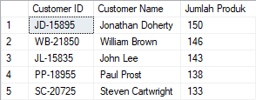

* 1. Nama pelanggan yang paling sering melakukan repeat order

select top 5 count(o.[Customer ID]) as 'Jumlah Repeat Order', cm.[Customer Name] from superstore_orders as o

full join superstore_customers as cm

on o.[Customer ID]=cm.[Customer ID]

group by o.[Customer ID], cm.[Customer Name]

order by count(o.[Customer ID]) desc

Output:

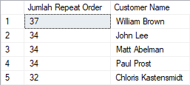

* 1. Dari kota mana pelanggan yang paling sering melakukan repeat order

select o.City as 'Kota Pelanggan Sering Repeat Order', cm.[Customer Name] from superstore_orders as o

full join superstore_customers as cm

on o.[Customer ID]=cm.[Customer ID]

where cm.[Customer Name]=

(select top 1 cm.[Customer Name] from superstore_orders as o

full join superstore_customers as cm

on o.[Customer ID]=cm.[Customer ID]

group by o.[Customer ID], cm.[Customer Name]

order by count(o.[Customer ID]) desc)

group by cm.[Customer Name], o.City

order by count(o.city) desc

Output:

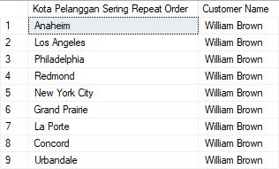

* 1. Order mana yang mendapatkan total discount paling kecil

select [Order ID], Discount from superstore_orders

where Discount in (0.1)

group by [Order ID], Discount

order by Discount asc

Output: 1-89 rows

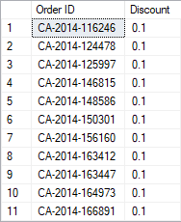 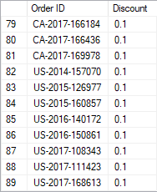

* 1. Total profit yang datang dari produk dengan sub category Furnishings & Supplies

select sum(Profit) as 'Total Profit' from superstore_orders as o

full join superstore_categories as ca

on o.[Product ID]=ca.[Product ID]

where ca.[Sub-Category] = 'Furnishings' or ca.[Sub-Category] = 'Supplies'

Output:



* 1. Jumlah order yang berasal dari produk warna hitam (terdapat keterangan “black” di nama produknya)

select count(o.[Order ID]) as 'Jumlah Order' from superstore_orders as o

full join superstore_categories as ca

on o.[Product ID]=ca.[Product ID]

where ca.[Product Name] like '%black%'

Output:



* 1. Jumlah order yang memiliki waktu pengiriman masih di hari yang sama dengan waktu pemesanan

select count([Order ID]) as 'Total Order' from superstore_orders

where [Order Date] = [Ship Date]

Output:



1. BI Engineer SQL Test #2

Write a SQL query to select the 2nd highest salary in the engineering department. If more than one person shares the highest salary, the query should select the next

highest salary.

select distinct e.salary from employees as e

inner join departments as d

on e.department_id=d.id

where d.name = 'engineering'

order by e.salary desc

limit 1,1

1. BI Engineer SQL Test #3

We’re given two tables, a users table with demographic information and the neighborhood they live in and a neighborhoods table. Write a query that returns all neighborhoods that have 0 users.

select n.name from neighborhoods as n

left join users as u

on n.id=u.neighborhood_id

where u.id is null